**BIRLA INSTITUTE OF TECHNOLOGY AND SCIENCE, PILANI**

Batch No. :

**DEPARTMENT OF COMPUTER SCIENCE AND INFORMATION SYSTEMS**

**Artificial Intelligence (BITS F444/ CS F407)**

**I Semester 2019-20**

**Programming Assignment-2**

**Coding Details**

**(September 27, 2019)**

*Instruction: Type the details precisely and neatly*

1. ID _____________________________________________________________

Name _____________________________________________________________

1. Mention the names of Submitted files :
   1. <filename.ext>
   2. <filename.ext>
   3. <filename.ext>
   4. <filename.ext>
   5. <filename.ext>
   6. <filename.ext>
   7. <filename.ext>
2. Total number of submitted files: ___________
3. Name of the folder :_________________________
4. Have you checked that all the files you are submitting have your name in the top?(yes/no)
5. Have you checked that all the files you are submitting are in the folder as specified in 4 (and no subfolder exists)?(yes/no)
6. Problem formulation
   1. State representation:
   2. How is the Initial state generated?
   3. What is the goal state?
   4. Are there more than one goal states? If yes, then describe all the goal states.
   5. Do you view the goal state as a state reaching its optimal heuristic value in a search landscape? Give details.
   6. State representation in Python (name the construct and give one small example of a state)
7. NextState() function description
8. Heuristic functions
   1. Is the heuristic function applied on a cell or on a state?
   2. Define and explain the heuristics (in words) used in your program. Specify the input and output to each function in detail
      1. h1 :
      2. h2 :
   3. Compute (manually) the heuristic values for the following three states state 1, 2 and goal state as given in the following three figures 1,2 and 3 respectively. Write the values below appropriately.

State1 : h1 = , h2 =

State2 : h1 = , h2 =

State2 : h1 = , h2 =

Goal state : h1 = , h2 =

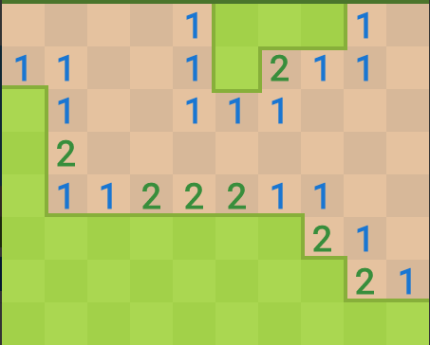

Fig 1

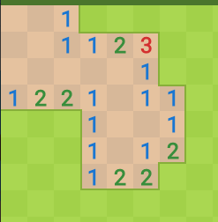

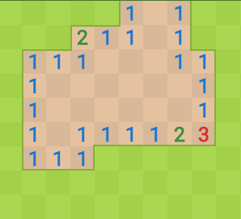

state 1 (your state should not have concavity as is here)

state 2 (convex shape of open area)

state 3 (convex shape of open area)

1. Hill Climbing (T1) technique
   1. Code status (implemented fully/ partially/ not done)
   2. Write the sequence of steps followed by you (choose words from - First click, next state, all next states, compute heuristic value, cell, state, open area, closed area, mine etc.)
   3. Print the pre-computed values

R1 = R2 = R3 = R4 = R5 = R6 = R7 = R8 = R9 = R10

* 1. Cut and paste the images of graphs G1, G2, G3 and G4 below
  2. Are you posing the problem as maximization problem or minimization problem? Discuss why.
  3. Discuss how you view the changing values of heuristics as you proceed.
  4. Discuss the state which represented suboptimal solution? Why?

1. Simulated annealing (T1) technique
   1. Code status (implemented fully/ partially/ not done)
   2. Write the sequence of steps followed by you (choose words from - First click, next state, all next states, compute heuristic value, cell, state, open area, closed area, mine etc.)
   3. Print the pre-computed values

R11 = R12 = R13 = R14 = R15 = R16 =

* 1. Cut and paste the images of graphs G5, G6 and G7 below
  2. Discuss the temperature range used.
  3. Discuss the probability computation.
  4. How are you selecting the bad moves?
  5. Are you posing the problem as maximization problem or minimization problem? Discuss why.
  6. Discuss how you view the changing values of heuristics as you proceed.

1. GUI details
   1. Created the GUI (yes/ No):
   2. Have created it according to the specifications?(yes/No)
   3. Which module of Python used for creating graphics?
   4. Is this under the standard Python library/ Matplotlib/ PyQT or not?
   5. If not, why?
2. Compilation Details:
   1. Code Compiles (Yes/ No):______________
   2. Mention the .py files that do not compile:___________________________________________
   3. Any specific function that does not compile:_______________________________________
   4. Ensured the compatibility of your code with the specified Python version(yes/no)____________
   5. Instructions for compilation of your files mentioning the multi file compilation process used by you (We may use the replica of these for compiling your files while evaluating your code)
3. Driver Details: Does it take care of the options specified earlier(yes/no):___________
4. Execution status (describe in maximum 2 lines)

1. Any other detail: ____________________________________________________________________ ____________________________________________________________________________________
2. Declaration: I, ____________________________ (name) declare that I have put my genuine efforts in creating the python code for the given programming assignment and have submitted only the code developed by me. I have not copied any piece of code from any source. If the code is found plagiarized in any form or degree, I understand that a disciplinary action as per the institute rules will be taken against me and I will accept the penalty as decided by the department of Computer Science and Information Systems, BITS, Pilani.

ID______________________________ Name:__________________________

Date: ______________

******************************************************************************* Should not exceed six pages